The Acquisition Center of Excellence (ACE) for Services Can Help You Achieve Your Agency Mission

ACE Statutory authority
The Service Acquisition Reform Act (SARA), Section 1431(b), requires OFPP to establish an Acquisition Center of Excellence (ACE) for Service Contracting. The purpose is to provide a central clearinghouse of service contracting best practices for both the public and private sectors.

An "on-line" resource
- Supports the acquisition community responsibilities;
- Graphically represents all the actions and/or requirements associated with a given decision or acquisition phase and allows you to drill down to the topic you need to research.

Target Audience
The Private and Public Sector Acquisition
Community including program managers,
Technical representatives, etc.

Partnerships are formed
OFPP
DAU and FAI
Federal Government Agencies
Associations and Industry Representatives

Project Questions:
julia_wise@omb.eop.gov
Or (202)395-7561

Technical Questions/Help:
jeffrey.birch@dau.mil
or (703) 805-3459



September 2004

ACquisition Center of Excellence (ACE) for services

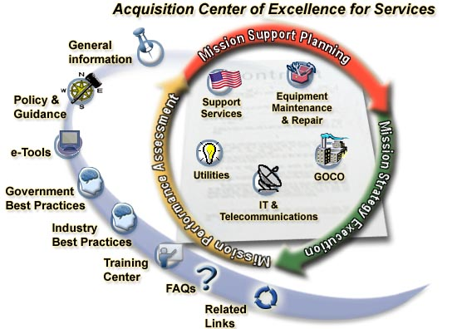

http://acc.dau.mil
What is ACE for Services?
A premier services source for both the public and private sector acquisition community to promote knowledge sharing and excellence in making smart business decisions.

Benefits of ACE for Services
Offers a collaborative structure that has proven to be extremely effective in the creation and transfer of knowledge within and between organizations, and provides value to organizations in the following ways:
- Provides a one stop resource information center for new/more junior employees and senior/more experienced practitioners;
- Facilitates the building of services knowledge;
- Facilitates the rapid identification of individuals with specific knowledge or skills;
- Fosters a collaborative knowledge sharing across organizational boundaries (“boundary spanning”); and
- Promotes and facilitates the capture and re-use of existing knowledge assets within the acquisition community.

Need Services Information Now?
ACE for Services Can Help.
- ACE for Services was developed to share information throughout the acquisition community to promote and share service contracting knowledge.
Features of ACC:
Features of the DAU ACC.
- Tables detailing statutory and regulatory requirements, guidebook links, and internet links.
- An Interactive interface
- Presentation of information in a variety of views/layouts
- Highlighted links for easy navigation from the requirements to suggested solutions and processes.
- Search capability
- Glossary of Acronyms
- Access to AT&L Acquisition Knowledge Support System (AKSS)
- Access to the Acquisition Community Connection (ACC) Community of Practice

Why use DAU’s ACC framework?
- This tool is working successfully in the DOD Community.
- Leveraging existing framework and resources.
- Building a partnership with an agency that spends over 50% of the service dollars.


How can you help your acquisition community?
- Join the partnership and help populate the site with services best practices by contacting julia_wise@omb.eop.gov ; or
- Suggest a link or contribute information directly to Jeffrey.birch@dau.mil.

